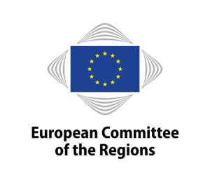

20 June 2019

**ALDE Group meeting, Wednesday 26 June 2019**

**10.30-13.00, Meeting room JDE 51, European Committee of the Regions**

**Draft agenda**

**1. Welcome and introductions**

**2. Adoption of the agenda**

**3. Approval of the minutes of the Group meeting on 10 April 2019**

**4. Discussion on the future of sustainable tourism: challenges and opportunities**

*Dorota TOMALAK, CoR Policy Expert on Tourism*

**5.****Post-European Elections 2019**

*- Update on the results and composition of the new parliament*

*- Decision to change the group name*

**6. Plenary preparation**

*a) Plenary debates*

**7.** **Update on the Rules of Procedure**

**8. Updates from the Bureau/ALDE coordinators/ALDE rapporteurs**

**9. Upcoming ALDE activities**

**10. Dates of the next meeting**

**11. Any other business**