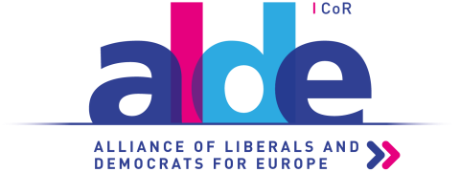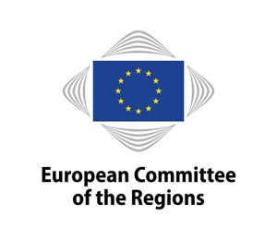

26 June 2018

**ALDE Group meeting, Wednesday 4 July 2018**

**10.30-13.00, Meeting room JDE 51, European Committee of the Regions**

**Draft agenda**

**1. Welcome and introductions**

**2. Adoption of the agenda**

**3. Approval of the minutes of the Group meeting on 16 May 2018**

**4. Discussion on the Future of Artificial Intelligence and Robotics**

*Presentation by Björn Juretzki, Policy Officer, European Commission*

**5. Presentation of the European Entrepreneurial Region (EER) Awards**

*Presentation by Bert Kuby, Head of Unit, ECON Commission*

**6. Plenary preparation**

*a) Plenary debates*

**7. Updates from the Bureau/ALDE coordinators/ALDE rapporteurs**

*a) Report back from the Task Force on Subsidiarity*

**8. Upcoming ALDE activities**

**9. Dates of the next meeting**

**10. Any other business**